HIRING CDL DRIVERS

FOR CARROLLTON /FB

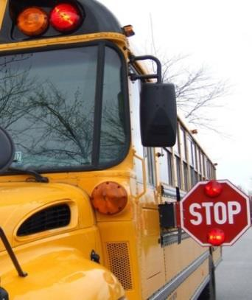

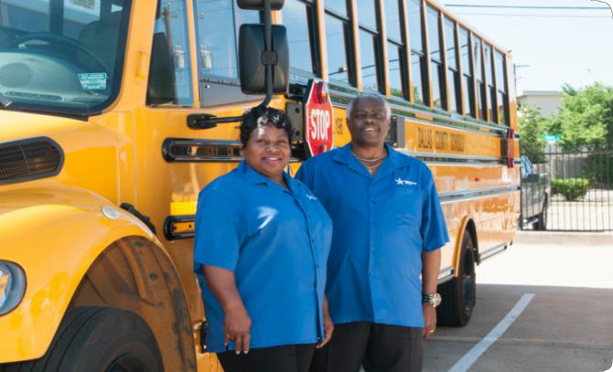
$15.50/HR Mininum

Training: $10.10/hr

PAID
5
HOLIDAYS
PAID
TRAINING
BENEFITS
AVAILABLE

MUST MEET THE
FOLLOWING REQUIREMENTS:
- Possess Good Communication Skills and Work Well with Children
- 18 Years or Older
- Must Have a High School Diploma, G.E.D. or Pass DCS Equivalency Exam
- Must Pass a Required Medical Examination
and Drug Screen
- Must Meet a Criminal History Check

FOR MORE INFORMATION CALL
972-968-6320 OR
214-944-4545
DCSCHOOLS.COM

rev. 06/4/15

SE SOLICITAN

CHOFERES DE AUTOBUS

$15.50/HR Mínimo

Entrenamiento: $10.10/hr

DIAS FESTIVOS PAGADOS
5

ENTRENAMIENTO PAGADO BENFICIOS
DISPONIBLES

REQUISITOS:

  - Habilidad de poder comunicarse en Ingles y poder trabajar bien con niños
  - Mayor de 18 años
  - Diploma de Escuela Secundaria, equivalente(GED) o poder pasar una prueba equivalente
  - Pasar examen médico y Antidoping
- Pasar verificación de antecedentes penales

PARA MÁS INFORMACIÓN LLAME A
214-944-4545 O

DCSCHOOLS.COM

rev. 06//15

