Spring 2017 Spanish Courses

Presenter:

Georgina Tezer
Wednesdays
Spanish I
Fun and fast-paced! We will cover vocabulary and grammar needed to communicate in Spanish at a basic level. Lots of practice! Expect homework.
30 hours – 10 weeks
February 15th – April 26th, 2017
6-9 p.m. ESDC Bldg. B, F. Branch Room
No classes on March 15th (Spring Break)

Register through Eduphoria on Staff Portal



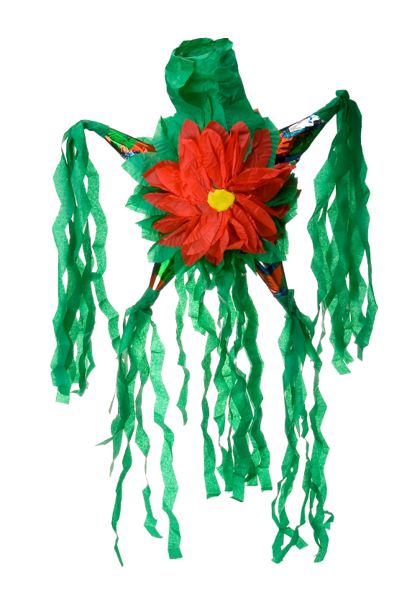

Thursdays
Spanish III
Follow-up to Spanish II. Course will cover all Indicative tenses and object pronouns, weekly news reports and discussions in Spanish. Expect homework and fun!
30 hours – 10 weeks
February 16th – April 27th, 2017
No classes on March 16th (Spring Break)
6-9 p.m. ESDC Bldg. B, F. Branch Room
Register through Eduphoria on Staff Portal

Fee: $50.00 (C-FB employees) $100.00 (all others)
1820 Pearl St. ESDC Bldg. B
Carrollton, Tx. 75006
C-FB employees: Register through Eduphoria on Staff Portal
All others: 972-968-6513 or tezerg@cfbisd.edu

