TEACHER ACTIVITIES

BIRD ADAPTATIONS AND SPECIES SURVEY

BACKGROUND:
Bird watching is enjoyed by millions of Americans of all ages. It is a hobby that can give pleasure at any place and at any time. Bird watching can also be used in scientific studies such as observing the changing conditions of habitats, or in the case of this activity, how birds have adapted to survive in different habitats.

Birds are by far the most popular of wildlife because they are easy to see, easy to identify, great in numbers and variety, beautiful to observe, attractive to hear and ever changing in occurrence and numbers. Even experts get many thrills from observing unusual or unexpected species.

Many skills are learned as one becomes a birder (bird watcher). Below are some skills any beginning bird watcher would want to know.

  - Having the right equipment such as binoculars and identification guides and knowing how to use them is helpful.

  - Knowing where to look is important. A place such as a moist woodland that contains food, water and shelter for the birds would be a good spot.

  - Knowing how to look is important. Most birds are active in the early morning hours and are easily frightened by movement so getting an early start, being quiet and remaining still helps to spot birds.

  - Knowing the parts of the bird such as the color of the primary feathers on the wing or the presence of a feather crest on the head might prove helpful in identifying.

  - Observing special adaptations of birds such as a unique behavior, the size of the bird, the shape of the bill, and color of the feet are some of the skills needed to identify birds.

OBJECTIVES:
- The student will become familiar with bird watching techniques using field equipment such as:
binoculars, bird identification books and plastic molds.
2. The student will study the relationship between structure and function of different bird adaptations which enable birds to survive in a variety of habitats.
3. The student will look for adaptations while bird watching to help to identify different bird species.
4. The student will record bird sightings on a chart to observe patterns of population changes.

MATERIALS:
1. 35 Binoculars
2.25 Golden guides on birds
4. Laminated copies of "Bird Adaptation Study" sheets
5. Birds of the Environment Set (Plastic molds of heads and feet of 10 bird species)

PROCEDURE:
1. Have students work with a partner.
2. The beginning background information for this activity should be read to the students.
3. Now have students recall some of the special adaptations different animals have to help them survive. Some examples to get them thinking are: the hard shell of a turtle for protection; the long neck of a giraffe for reaching food; or the chameleon changing color to hide.
**This quick activity will help introduce students to the next part.
4. Use the "Birds of the Environment Set" to show examples of bird adaptations. Students can try to match the plastic molds of bird feet with molds of bird beaks.
5. Discuss reasons why the different bird parts match.
(See red notebook in kit for explanations.)
6. Pass out bird identification guides and discuss how to use the book. Be sure to include how to use the index (last pages of book), the pages at the beginning of the book which show how to read the maps for each bird species pages 10 or 12.
7. Pass out laminated copies of "Bird Adaptations Study" and discuss. (See following pages)
8. Read through student activity sheet with students and discuss how to fill in the table with the information below (see following page for student worksheet).
  - Students will list the bird species correctly identified along with a close estimate of the number seen.
  - Students will list the general habitat type of where each bird species is seen such as a wooded area, grassland area, pond area, barn area, etc.
  - Students will list each bird species bill type, feet type, wing adaptation and tail adaptation which help it survive. This information can be gathered from the laminated handouts or bird guides.
  - Students will list the best visible marking of each species. These are characteristics which would help to easily identify each bird species.
- Pass out binoculars and demonstrate proper use. Most binoculars have two adjustments. One is on right eye piece and the other is in the middle of the binoculars.
- Identify birds at feeder station if present and have students begin filling in their answer sheet.
- Then lead students on a hike to observe birds at other locations. (Ex. Along the gravel road, near the grassland area or the barn area). Make sure students bring materials along to help identify each species observed.
- After completing hike, list the species seen and their number on the "Bird Species Survey". Discuss any patterns seen with the survey. (Note: It may be fun to have a little competition between classes to see which group can find and identify the most species of birds.)
- Clean up activity area and return all materials. (Count binoculars to help insure their return.)

NOTE: In the event that no birds are seen have students look up specific bird species in the guides and discuss their adaptations.
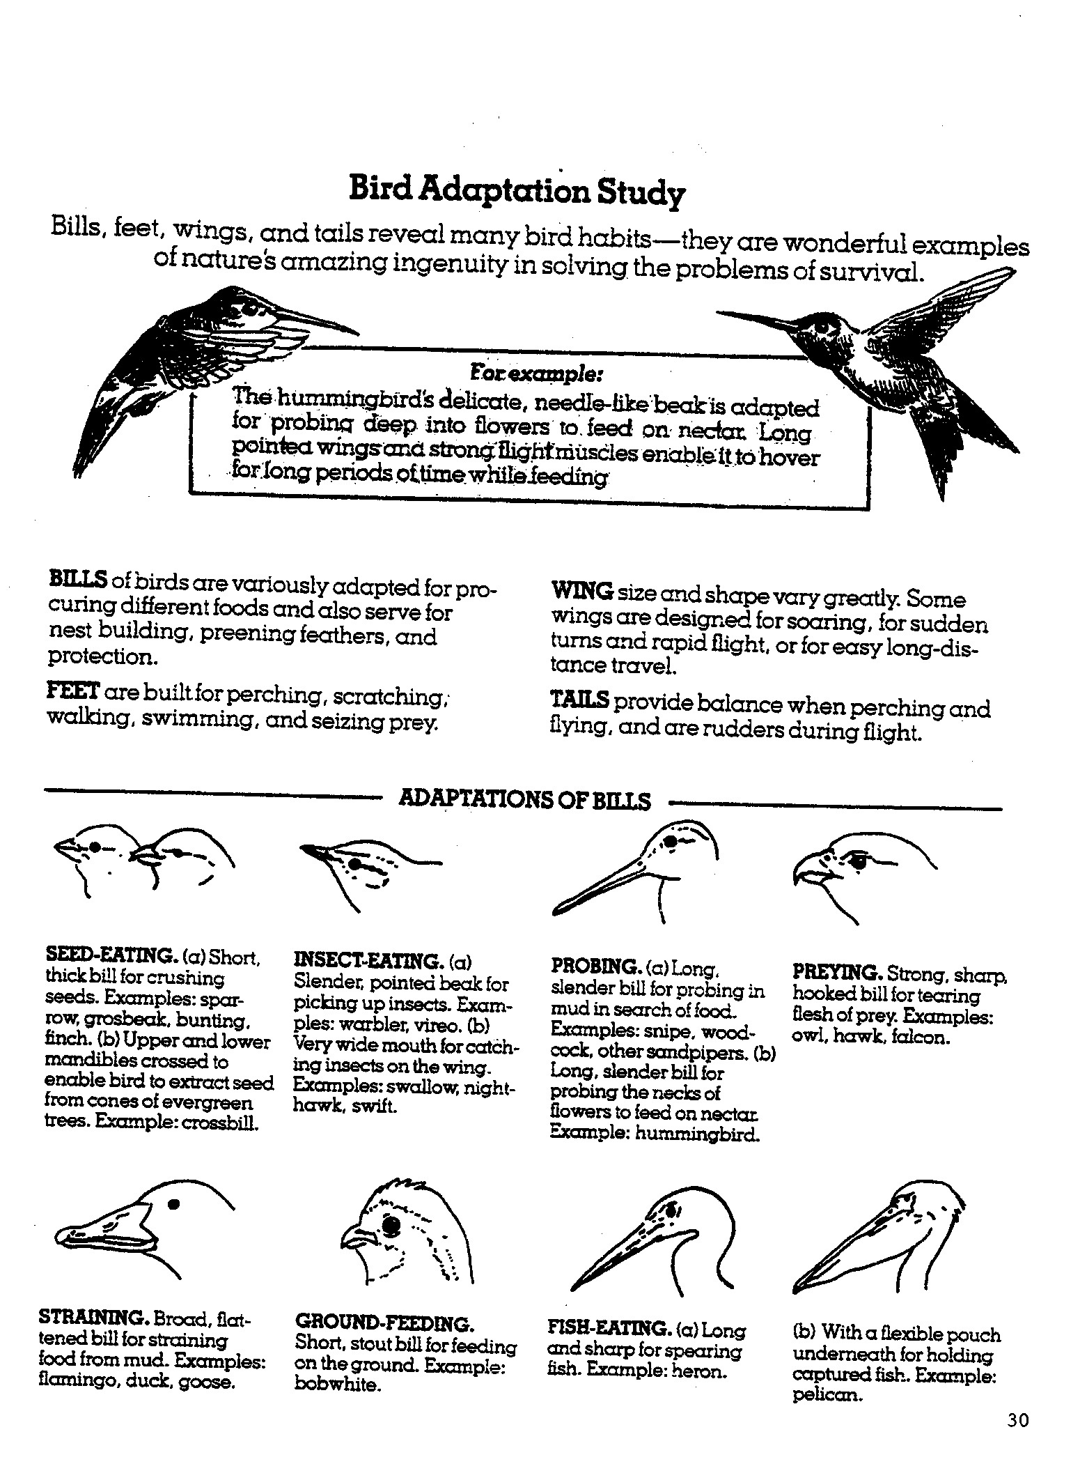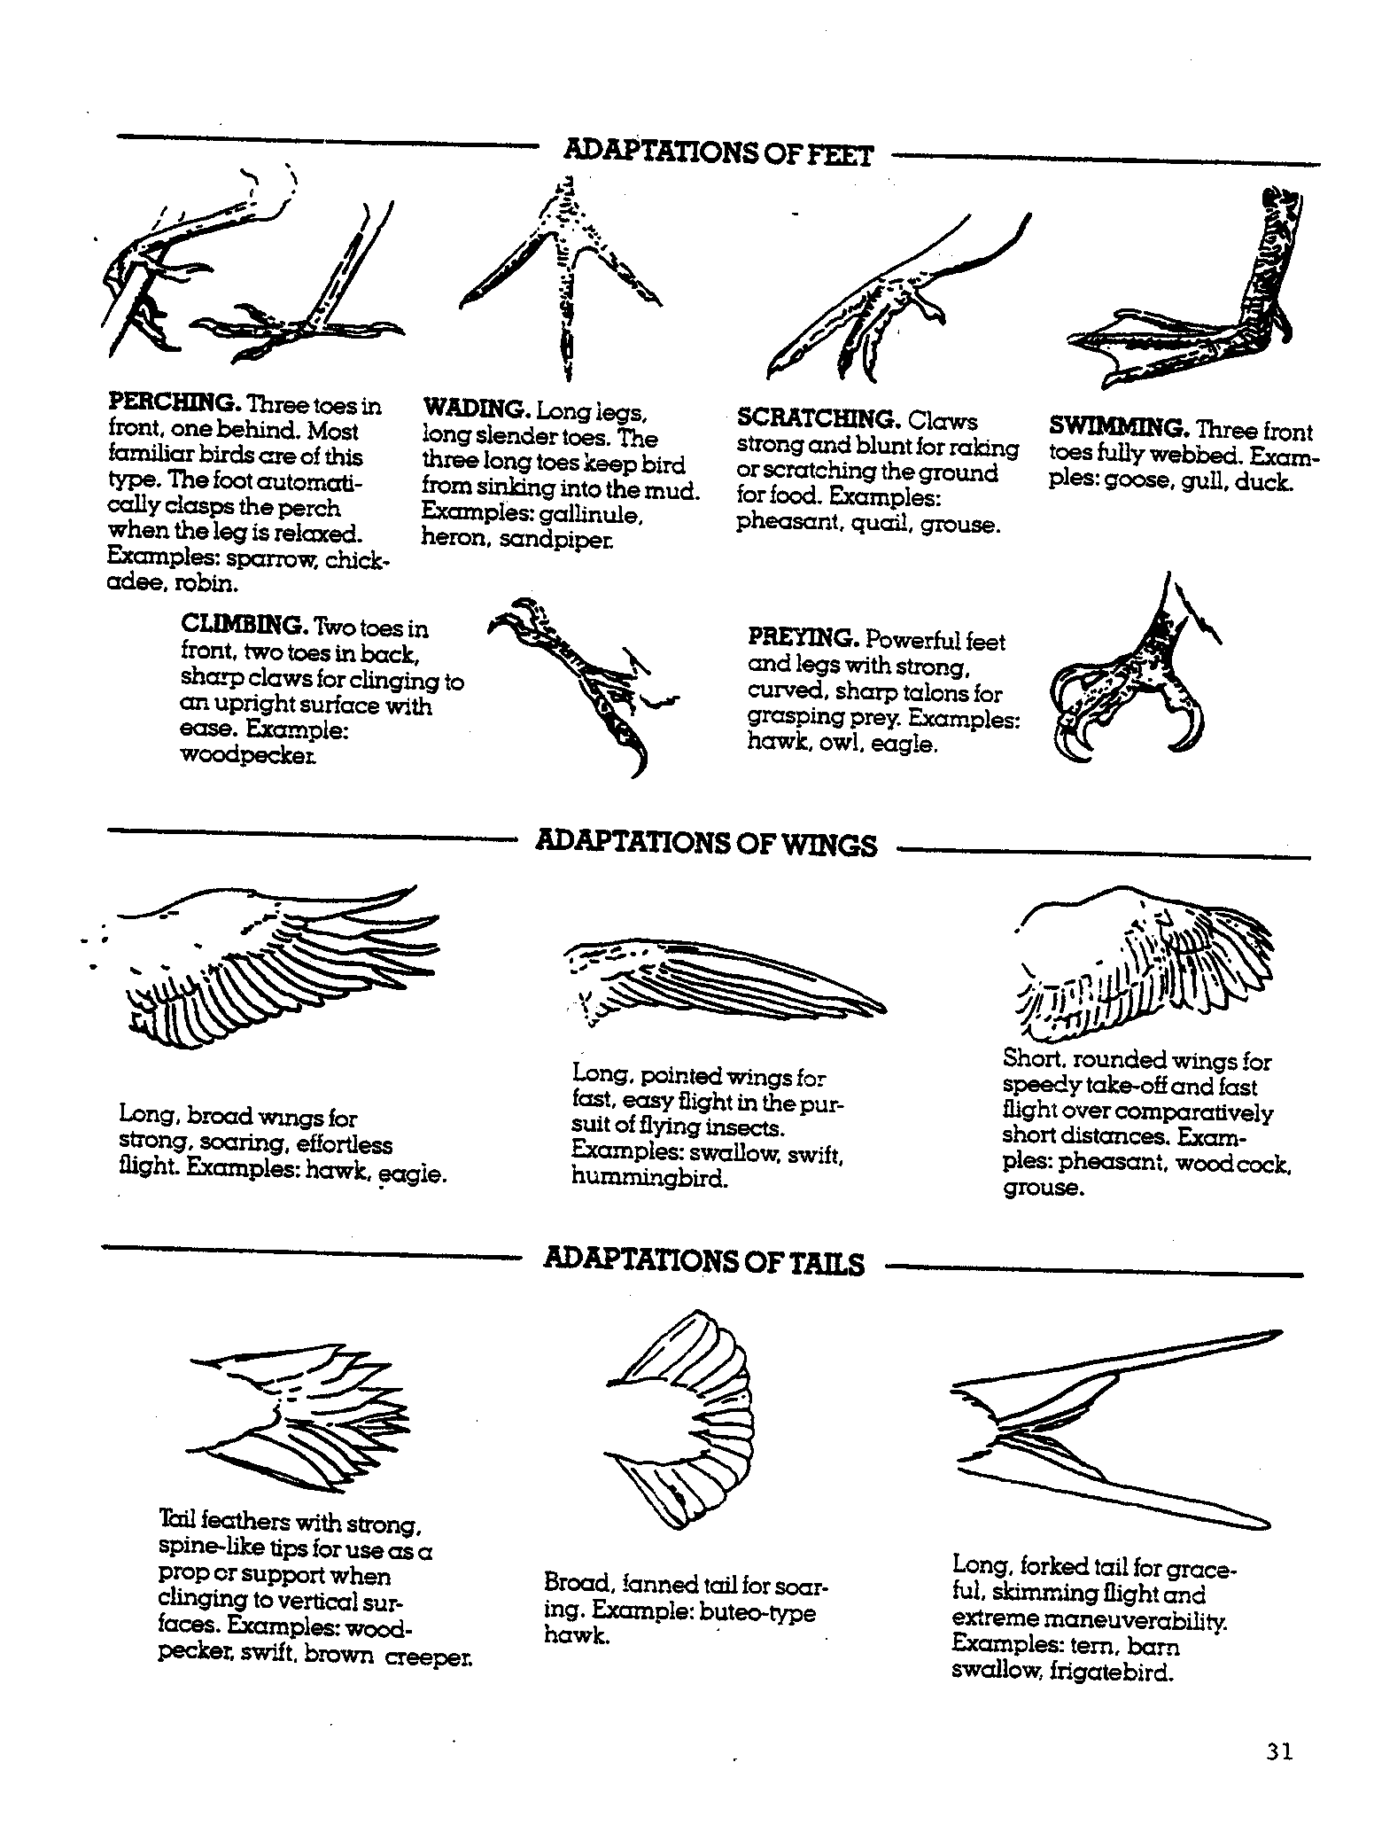

ADAPTATIONS OF BIRD SPECIES
Directions:
- Listen to the teacher’s instructions on how to use binoculars, bird identification guides and student worksheet.

- Wait patiently for your equipment to be handed out and then quietly follow the teacher as you search for birds at the Outdoor Learning Center.

- When you find a bird, you should identify the species type using the binoculars and identification guides. In the spaces provided, fill in the bird species name, number of birds seen and the types of adaptations.

- Return binoculars, bird identification books and laminated bird adaptations chart.

Bird Species | Example  Great Horned  Owl
Number  Seen | 1
Habitat Type | Wooded Areas
Bill Adaptation | Preying
Feet Adaptation | Preying
Wing Adaptation | Long  Broad
Tail Adaptation | Broad
Best Visible Markings | Ear Tufts

