TEACHER ACTIVITIES
HABITAT STUDY

BACKGROUND:
The Outdoor Learning Center is a 42-acre plot of land located in a flood plain along the Elm Fork of the Trinity River. Several habitats are located within the 42 acres. The two habitats compared in this activity are a mowed field containing a stock pond (field/pond habitat) and a wooded area adjoining the Trinity River (forest/river habitat).

Electronic probes will be used to collect data from the two habitats. The types of probes are listed below.

- Thermistor – The probe measures temperature. Temperature is the degree of hotness or coldness of a body or environment. All measurements are will be calculated in degrees Celsius.
- Opacity/turbidity probe – The probe measures the amount of light passing through a liquid. It gives an indication of how muddy or clear a body of water appears.
- Light Sensor – The probe measures light intensity.

OBJECTIVES:
- Students will use the “LABQUEST 2” system to compare components of two habitats to which organisms may respond.
- Students will collect data from a forest/river habitat and a field/pond habitat.
- Students will construct charts and graphs to examine and evaluate the data collected.
- Students will formulate conclusions based on the results.

MATERIALS:
- Twelve LABQUEST 2 systems
- Probe types:
- Thermistor
- Light Sensor
- opacity/turbidity probe
- test tubes
- Laminated directions
- Laminated chart (for recording results)

PROCEDURE:
- Have students to work in a group of two or three (totaling eight groups) and assign each group a number one through eight.
- Point out that each of the eight groups will be gathering data to share with the entire class. Each group’s data will be posted on the laminated chart so all the data can be analyzed.
- At this point, assign each group member a specific job.
- Pre-programmer – Sets up the “LabQuest” to collect data at table area.
- Data Collector – Controls “LabQuest” while data is collected at habitat site
- Probe Handler – Manipulates probe at test area
- Group Recorder – Retrieves and records data from the “LabQuest”.

- Let students know the equipment is expensive and must be handled with extreme care. Discuss the information on the student answer sheet. Be sure to show each group where on the answer sheet they will record the data they collect. Also point out the probe type they will use and where they will collect the data. (See chart on student sheet or information in step 5 below.)
- Each LabQuest should have an assigned habitat and a specific probe. Each LabQuest should have one probe plugged into channel 1. Channels 2 and 3 will not be used.
- Groups 1, 2, 3 and 4 will visit Forest/River habitat.
- Group 1 will test for Air Temperature
- Group 2 will test for Water Temperature
- Group 3 will test for Water Turbidity
- Group 4 will test for Light Intensity
- Groups 5, 6, 7 and 8 will visit Field/Pond habitat.
- Group 5 will test for Air Temperature
- Group 6 will test for Water Temperature
- Group 7 will test for Water Turbidity
- Group 8 will test for Light Intensity

- Pass out the numbered LabQuest to each group’s “Pre-programmer”. Each group should have the LabQuest that corresponds to their group number.
- Demonstrate how to use each of the three probes to the entire class. Remind everyone that each group will only be using one probe in only one habitat type. Later, when the groups are at the testing areas you may need to again demonstrate how to place the probes into the sample areas.
- Pass out pink laminated sheets (Procedure for LabQuest Use) to each group’s recorder. The students will follow along as you read the information out loud.
- The “Pre-programmer” should be completing each step as you read them.
- During this process each LabQuest will need to be set to collect data in 10-second increments for a total of thirty seconds.
- Have students do a practice run by collecting data on the LabQuest while students are still together as a class in the seating area.
- Discuss safety procedures to students.
- The forest habitat does contain poison ivy so stay on cleared pathways.
- The riverbank and around the pond may be muddy and slippery so watch your step.
- Students should stay with the teacher at all times.
- Handle equipment carefully to prevent injuries.
- Lead students to each habitat type and let the assigned groups collect their data. Be sure to monitor progress of students.
- Return to activity area to transfer data from the LabQuest systems to the activity or data sheets. The recorder of the group will transfer the data to the laminated chart.
- Students should answer questions on activity sheet. Lead the class in a discussion about how to analyze data and report their results.
- Return LabQuest units in storage containers to equipment table and make sure each LabQuest is turned off to save battery power.

PROCEDURE FOR “LABQUEST ” USE

BACKGROUND: Quick pointers to make sure the LabQuest works properly are:
- Use attached Stylus to select on screen buttons. Touch screen gently.
- The information on the display screen should change if the buttons are pressed properly.
- Keep the LabQuest unit in the plastic container to protect it from mud and water.

PROCEDURE:

- Turn on Power by pushing down the small oval symbol on the side of LabQuest. | 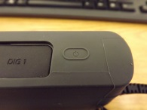
- Beginning Screen – You should see number values on red screen and the name of the probe you have plugged into the LabQuest. | 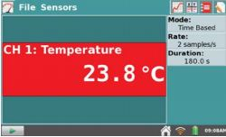
- Now change Default settings for our experiment at the Outdoor Learning Center. Use stylus to select buttons on screen. | 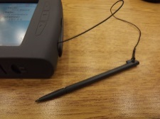
- Use stylus to select the Duration: icon | 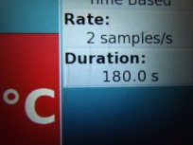
- Now select the white rectangular box next to Duration and change the number to 30 seconds. | 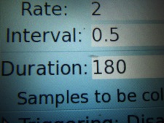
- Point stylus on the 3 and 0. | 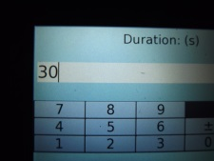
- Now select the Done icon. | 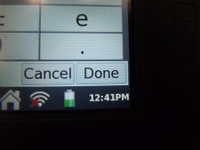
- Select the white rectangular box next to the Interval: icon and change the number to 10 seconds. | 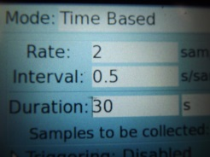
- Point stylus on the 1 and 0. | 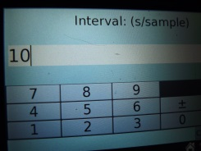
- Now select the Done icon. | 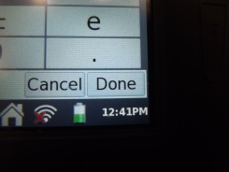
- Under the Duration icon you should see the statement “Samples to be collected: 4” | 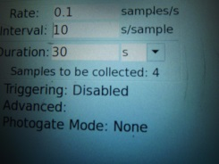
- Now select the OK icon in lower right corner. | 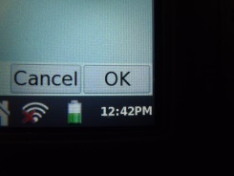
- To practice collecting data, select the green arrow icon at the bottom left side of the screen. | 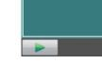
- After 10 seconds data points will begin to appear in a graph on the screen. | 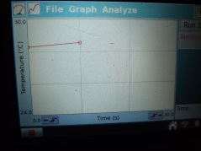
- The red square at the bottom indicates the data is being stored on the computer. The green arrow will reappear once the LabQuest is done collecting data (approximately 30 seconds). | 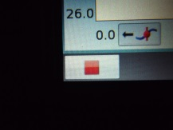
- Use stylus to select the gray filing cabinet next to the Run 1 icon. | 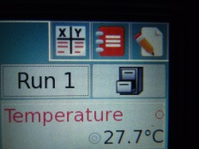
- A Run 2 icon will appear. | 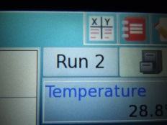
- You are now ready to gather information from the habitat. Once you are at the river or pond, the “Probe Handler” should place probe in desired location. Wait 30 seconds and then the “Data Collector” should start Run 2 by selecting the green arrow.
- The red square will appear again followed by the green arrow once it is finished collecting data. You are now done collecting data so select the Data Table icon with the “X, Y” at the top right of the screen. | 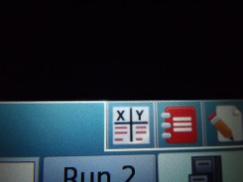
- You should see the measurements you collected in a data table in Run 2. Gather up equipment and return to seating area. Record those four data points from Run 2 on your answer sheet. Remember Run 1 was practice data. | 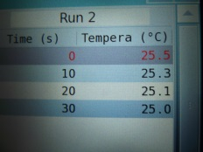
- Turn off power by pressing the symbol ᶲ on the side of LabQuest. | 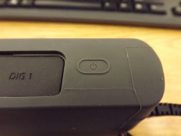
- Use the stylus to select the Discard icon at the bottom of the screen to delete the unsaved data. Return LabQuest units with storage container to equipment table and check to make sure each LabQuest is turned off to save battery power. | 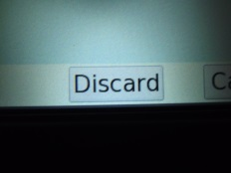

Student name _____________________ HABITAT STUDY
DIRECTIONS:
- You will compare different habitat types using the “LabQuest 2” system (a hand held computer technology that contains probes for the collection of data). Listen carefully to the teacher’s instructions on how to use the computer probes.
- Carefully place probes in desired locations and start recording in ten second increments for a total of thirty seconds.
- Record the collected data in the chart below and answer the questions that follow.

PROBE TESTS | FOREST/RIVER HABITAT |  |  |  |  |  |  | FIELD/POND HABITAT
Air  Temperature °C | LabQuest  #1 |  |  |  |  |  |  | LabQuest  #5
Water  Temperature °C | LabQuest  #2 |  |  |  |  |  |  | LabQuest  #6
Water  Turbidity (NTU) | LabQuest  #3 |  |  |  |  |  |  | LabQuest  #7
Light Intensity (lux) | LabQuest  #4 |  |  |  |  |  |  | LabQuest  #8
 |  | 0 |  | 10 | 20 |  | 30 | 0 |  |  | 10 | 20 |  | 30
 | Time (10 Second Intervals) |  |  |  |  |  |  | Time (10 Second Intervals)

- Compare the results of the air temperature data collected at each habitat. Is there a difference? ________________ Give a possible explanation.

- Compare the results of the water temperature data collected at each habitat. Is there a difference? ______________ Give a possible explanation.

- Compare the results of the water turbidity data collected at each habitat. Is there a difference? _________________ Give a possible explanation.

- Compare the results of the light intensity data collected at each habitat. Is there a difference? ______________
Give a possible explanation.

- Create a graph below using the results from one of the probe tests that compares the two habitat types. Place an X for each of the four “Forest/River” habitat data points and place an O for each of the four “Field/Pond” habitat data points. You will need to determine which numbers to use for the y axis/probe test side.

Forest/River X
Pond/Field O
Field/Pond O

Probe
Test
“___________”

0 10 20 30
Time (10 Second intervals)

HABITAT STUDY - GROUP RESULTS

PROBE TESTS | FOREST/RIVER HABITAT |  |  |  |  |  |  | FIELD/POND HABITAT
Air  Temperature °C | LabQuest  #1 |  |  |  |  |  |  | LabQuest  #5
Water  Temperature °C | LabQuest  #2 |  |  |  |  |  |  | LabQuest  #6
Water  Turbidity (NTU) | LabQuest  #3 |  |  |  |  |  |  | LabQuest  #7
Light Intensity (lux) | LabQuest  #4 |  |  |  |  |  |  | LabQuest  #8
 |  | 0 |  | 10 | 20 |  | 30 | 0 |  |  | 10 | 20 |  | 30
 | Time (10 Second Intervals) |  |  |  |  |  |  | Time (10 Second Intervals)

PROBE TESTS | FOREST/RIVER HABITAT |  |  |  |  |  |  | FIELD/POND HABITAT
Air  Temperature °C | LabQuest  #1 |  |  |  |  |  |  | LabQuest  #5
Water  Temperature °C | LabQuest  #2 |  |  |  |  |  |  | LabQuest  #6
Water  Turbidity (NTU) | LabQuest  #3 |  |  |  |  |  |  | LabQuest  #7
Light Intensity (lux) | LabQuest  #4 |  |  |  |  |  |  | LabQuest  #8
 |  | 0 |  | 10 | 20 |  | 30 | 0 |  |  | 10 | 20 |  | 30
 | Time (10 Second Intervals) |  |  |  |  |  |  | Time (10 Second Intervals)

PROBE TESTS | FOREST/RIVER HABITAT |  |  |  |  |  |  | FIELD/POND HABITAT
Air  Temperature °C | LabQuest  #1 |  |  |  |  |  |  | LabQuest  #5
Water  Temperature °C | LabQuest  #2 |  |  |  |  |  |  | LabQuest  #6
Water  Turbidity (NTU) | LabQuest  #3 |  |  |  |  |  |  | LabQuest  #7
Light Intensity (lux) | LabQuest  #4 |  |  |  |  |  |  | LabQuest  #8
 |  | 0 |  | 10 | 20 |  | 30 | 0 |  |  | 10 | 20 |  | 30
 | Time (10 Second Intervals) |  |  |  |  |  |  | Time (10 Second Intervals)

