TEACHER ACTIVITIES
PONDWATER TOUR TEST KIT
BACKGROUND:
See information on following pages.

MATERIALS:
- Test kits (each kit contains one vial with cap, one syringe, three plastic bags labeled, pH, nitrogen and ammonia.
- Color charts (laminated)
- Test tablets in plastic container with divided compartments.
- pH tablets (1 per test)
- Dissolved oxygen tablets (2 per test)
- Ammonia test tablets (#1 and #2 tablet each)
- Nitrate test tablets (#1 and #2 tablet each)
4. Bucket for trash (tablet packaging)
5. Buckets with rinse water (clean pond water) to clean equipment

PROCEDURE:
- Have students get into groups of four and sit at the picnic tables.

- Discuss what kind of information can be obtained from doing water testing and why (see following pages in OLC Guide). It is important to stress that the water testing will help to determine if the pond is healthy. If healthy, chances are students will find organisms in the pond when sampling with the dip nets.

- Show students a kit and demonstrate how to use it. Students will have an explanation of how to do the experiment on their answer sheet. There will be one test for each student. The four tests are Dissolved Oxygen, Dissolved Nitrates, Ammonia, and ph.

- Have students collect water samples from south pond using syringes. The clearer the water, the easier it is to read results. It works well to have students collect water samples in a relay fashion starting with the students assigned to do the Dissolved oxygen test. Once they have collected a sample then the nitrates testers should collect a sample, then ammonia and finally the pH testers. (fewer students at the pond at one time works best.)

- When students have returned to the tables they should add the tablets. Make sure the correct tablets are used for each test.

- Students should check for color changes with tests and match the color of the liquid with the laminated color charts. The amount of color change will indicate the presence or concentration of the chemicals being tested.

- Students should record results on answer sheet and then rinse out bags and small vial for the next group.

- Have students place all equipment back into kits and return them to you for check in.

- Discuss results with students. Hopefully, the results will show high dissolved oxygen, a pH between 6 and 9, low or no ammonia and low or no nitrates. These results represent a healthy pond and students should catch organisms with the dip nets.

- When the water testing part of the activity is done you can start the pond sampling with dip nets.

POND WATER STUDY
DIRECTIONS:
- Form groups of four and sit across from your partners at the picnic tables.
- Each group receives a pond water test kit with one large syringe, three plastic bags, and a small vial with black cap.
- Each person in the group performs one of the water tests listed below and shares results with the group. Decide within your group which test each will perform and read the water testing directions carefully.
- The teacher hands out tablets to test your pond water sample in the order that they are listed below.
- Be sure to put foil from the tablet package in the trash bucket.
- When your test is finished, empty the contents of bag/bottle on the ground and rinse with clean pond water.
- Replace materials in kit and share results with group.

DISSOLVED OXYGEN TEST (approx. 10 min.)
- Remove cap from the little glass bottle. Gently submerge the tube below the surface of the pond water. Make sure that there are no air bubbles in the tube.
- Remove the tube from the water. The tube should be full to the very top of the tube.
- Add two D.O. Test Tabs to the tube. A little water will spill out of the tube.
- Carefully screw the cap onto the tube. More water will spill out of the tube.
- Slowly invert the tube back and forth until the tablets disintegrate. (This takes about 4 minutes).
- Wait 5 more minutes for an orange or pink color to develop.
- Compare the color of water in the vial to the Color Chart Poster.
- Record the Dissolved Oxygen test result as High, Low or None.
Result: | High | Low | None

NITROGEN TEST (approx. 8 min.)
- Use large syringe to fill a bag to line C with the pond water. Try not to suck up any plants, dirt, or fish.
- Add one Nitrate #1 Test Tab. Roll the bag down and shake until the tablet disintegrates. (This takes about 30 seconds.) DO NOT pinch or squeeze the tablet in the bag or the bag may be damaged--just shake it!
- Open the bag. Add one Nitrate #2 CTA Test Tab. Roll the bag down and shake until the tablet disintegrates. (This takes about 2 minutes.) DO NOT pinch or squeeze the tablet in the bag or the bag may be damaged--just shake it!
- Wait 5 more minutes for red color to develop.
- Compare the color of water in the bag to the Color Chart Poster.
- Record the level of Nitrogen as high, medium, low or none.
Result: | High | Medium | Low | None

AMMONIA TEST (approx. 8 min.)
- Use large syringe to fill a bag to line C with the pond water. Try not to suck up any plants, dirt, or fish.
- Add one Ammonia #1 Test Tab and one Ammonia #2 Test Tab. Roll the bag down and shake until the tablets disintegrate. (This takes about 3 minutes.) DO NOT pinch or squeeze the tablet in the bag or the bag may be damaged -- just shake it!
- Wait 5 more minutes for a yellow or green color to develop.
- Compare the color of water in the bag to the Color Chart Poster.
- Record the level of Ammonia as high, medium or None.
Result: | High | Medium | None

pH TEST (approx. 1 min.)
- Use large syringe to fill a test bag to line C with the pond water. Try not to suck up any plants, dirt, or fish.
- Add one pH Wide Range Test Tab. Roll the bag down and shake until the tablet disintegrates. (This takes less than 30 seconds.) DO NOT pinch or squeeze the tablet in the bag or the bag may be damaged -- just shake it!
- Compare the color of water in the bag to the Color Chart Poster.
- Record the result of your pH test below.
Result: | 5 | 6 | 7 | 8 | 9 | 10

WHAT IS PH?
Acidic and basic are two extremes that describe chemicals, just like hot and cold are two extremes that describe temperature. Mixing acids and bases can cancel out their extreme effects; much like mixing hot and cold water can even out the water temperature. A substance that is neither acidic nor basic is neutral.
The pH scale measures how acidic or basic a substance is. It ranges from 0 to 14. A pH of 7 is neutral. A pH less than 7 is acidic, and a pH greater than 7 is basic. Each whole pH value below 7 is ten times more acidic than the next higher value. For example, a pH of 4 is ten times more acidic than a pH of 5 and 100 times (10 times 10) more acidic than a pH of 6. The same holds true for pH values above 7, each of which is ten times more alkaline—another way to say basic—than the next lower whole value. For example, a pH of 10 is ten times more alkaline than a pH of 9.
Pure water is neutral, with a pH of 7.0. When chemicals are mixed with water, the mixture can become either acidic or basic. Vinegar and lemon juice are acidic substances, while laundry detergents and ammonia are basic.
Chemicals that are very basic or very acidic are called “reactive.” These chemicals can cause severe burns. Automobile battery acid is an acidic chemical that is reactive. Automobile batteries contain a stronger form of some of the same acid that is in acid rain. Household drain cleaners often contain lye, a very alkaline chemical that is reactive.
The following diagram shows the pH scale and the pH of some common items:
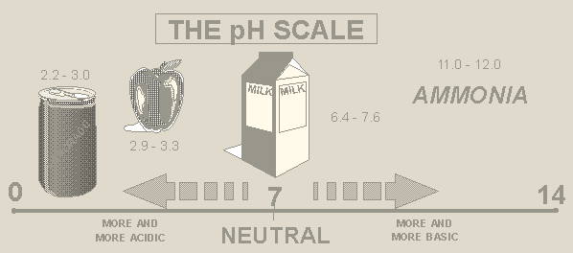

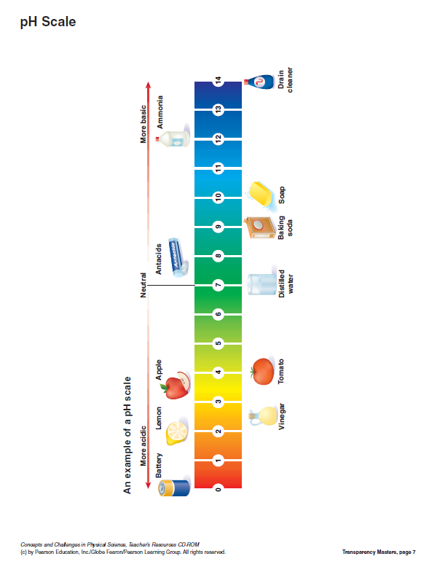

TEACHER ACTIVITIES
AQUATIC SAMPLING WITH DIP NETS

OBJECTIVE:
Students will learn how to use aquatic dip nets and collect samples from the pond. Students will identify the organisms they collect using observation tools and identification guides.

MATERIALS:
- Dip Nets
- Plastic Viewing Containers
- Golden Guides (Pond Life)
- Bucket (used to collect water for viewing containers)

PROCEDURE:
- Discuss what type of organisms might live in the pond including plants. Example might be crayfish, fish, snails, clams, shrimp, water beetles, dragonfly nymphs, small crustaceans, algae, salamanders and tadpoles.

- Demonstrate how to use the aquatic dip net and how to pick up and place the collected organisms into the plastic containers. Be sure to point out where students are to collect the organisms.

- Students should then identify the organisms by using the Golden guide "Pond Life".

- Pass one net to each pair and let all pairs began taking turns dipping the net into the pond.

- When time is up, have students carefully place animals back into pond, wash equipment and place nets in a neat stack. (Add fresh water to viewing containers for each group.)

- Students should fill in the student page “Is the pond polluted or clean? Ask the bugs!” to determine the health of the pond.

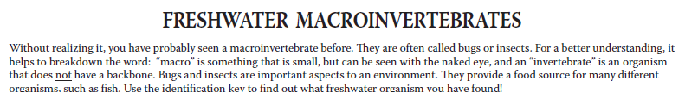
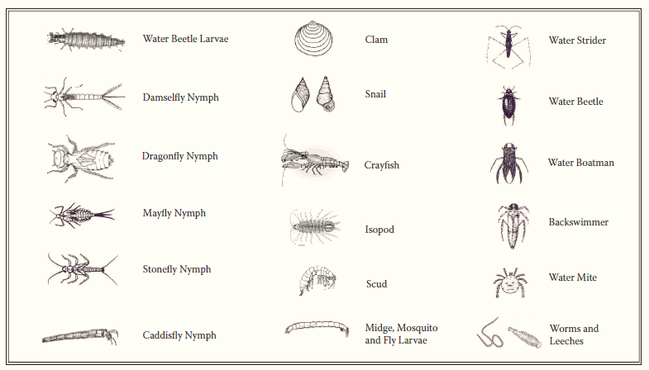

Adapted from NYSDEC Dept. of Public Affairs and Education’s Pond Study lesson plan

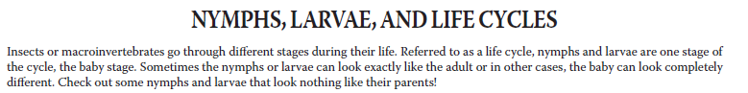
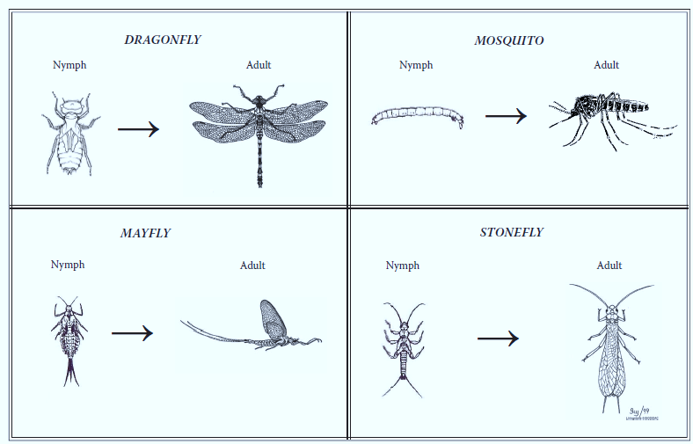

Adapted from NYSDEC Dept. of Public Affairs and Education’s Pond Study lesson plan

IS THE WATER CLEAN OR POLLUTED? ASK THE BUGS!

Many types of small invertebrates live on the rocks and plants at the bottoms of creeks, rivers, and ponds. Some types of aquatic (water-loving) invertebrates need very clean water to live. These animals are said to be intolerant. Some invertebrates can live in any water, whether polluted or not. These creatures are said to be tolerant. By recognizing the different types of aquatic invertebrates, we can learn whether the water here is clean and healthy for other wildlife.

Directions: Circle the picture of each invertebrate we found. Follow the directions at the bottom of each column, add the three totals, and decide which statement below is correct.

The water is clean if all the points’ added total is more than 19.
The water is okay if all the points’ added total is more than 9 but less than 20.
The water may be polluted if all the points’ added total is less than 10.

The water here is: clean _________________ OK _________________ possibly polluted _________________

Clean water animals  (pollution tolerant) |  | Fair water animals  (somewhat tolerant) |  | Polluted water animals  (pollution tolerant)
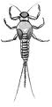  mayfly | 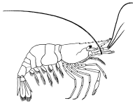  fresh water shrimp | 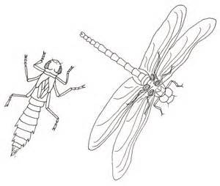  dragonfly nymph | 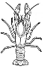  crayfish | 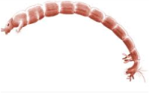  bloodworm | 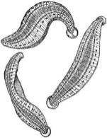  leech
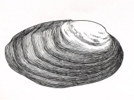  mussel | 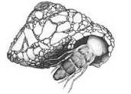  caddisfly | 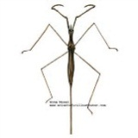  water scorpion | 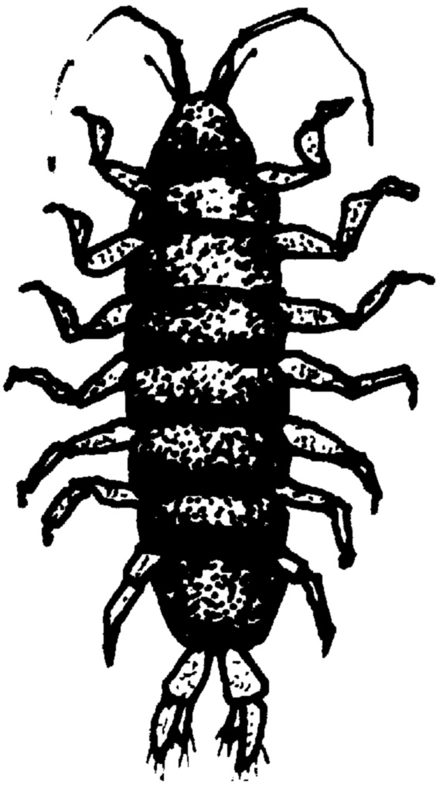  Aquatic isopod | 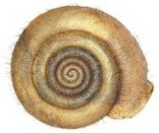  coiled snail | 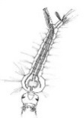  Mosquito Larva
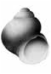  Hydrobiid snail | 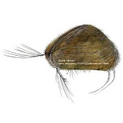  Clam Shrimp | 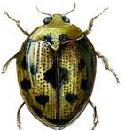  aquatic beetle | 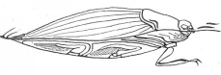  Whirligig beetle | 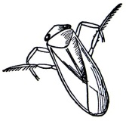  water boatman | 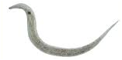  threadworm
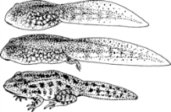  frog or tadpole | 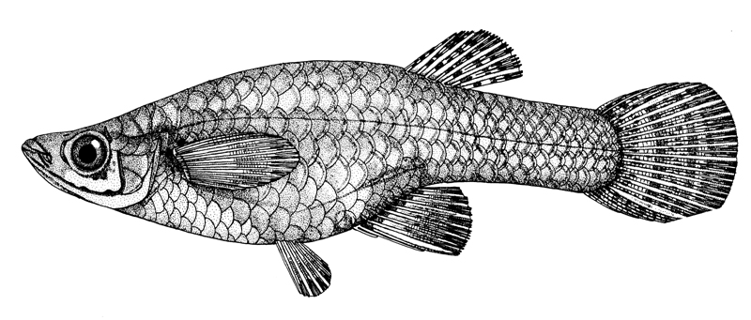  Mosquito Fish | 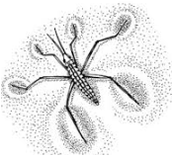  water strider | 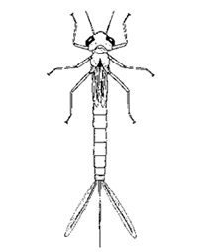  damselfly Nymph | 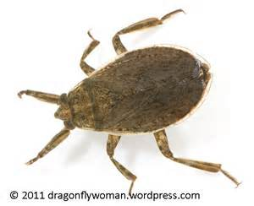  backswimmer | 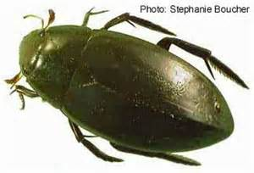  giant water bug
Multiply total circled by 3  TOTAL POINTS = __________ |  | Multiply total circled by 2  TOTAL POINTS = __________ |  | Multiply total circled by 1  TOTAL POINTS = __________

TOTAL POINTS = ___________

Illustrations from A Guide to Common Freshwater Invertebrates of North America by J. Reese Voshell, Jr. and Amy Bartlett Wright

