TEACHER LED ACTIVITIES
BARN TOUR AND NATURE HIKE
OBJECTIVES:
The student will learn about the High School FFA (Future Farmers of America) program and visit the animals in the FFA barns.

The student will explore a forested nature trail to observe points of interest and participate in an “Unnatural Hike” (students identify items placed along the trail that do not naturally occur in a river bottom habitat).

PROCEDURE:
- The teacher will begin the activity by gathering the students near the north end of the barns near the bathroom area. Let the students know they will be guests in the barn area and need to be respectful to the animals. Making loud noises and running in barns might scare the animals and cause them to injure themselves.

- The teacher will then lead the students through the FFA Barns. Students may pet the animals but be sure to practicing safety measures such as keeping your fingers away from their mouths. Livestock usually seen are pigs, sheep, goats, cows, and rabbits. The teacher can describe how the high school students take care of the animals and prepare them for show at events like the State Fair and Ft. Worth Stock Show.

- The teacher will then lead the students along a wood chipped path that parallels Denton creek. Along the way they will look for signs of beavers, armadillos, insects, birds and any other interesting signs of animal or plant life. A nature guide with corresponding markers is also used to help show points of interest.

- As part of the “Unnatural Hike”, students will look for items they think do not naturally occur in a river bottom habitat. Ten different unnatural items will be placed on the trail. Some possible examples of unnatural items that will be placed on the trail are: rubber hose, clipboard, stuffed animals, fishing string, clothing, science equipment (test tubes, beakers), binoculars, watering can, masking tape, office supplies (stapler, tape, scissors), light bulb, tools, apron, etc.

On the date of the visit, teachers leading the hike can request a list of items that have been placed along the trail. The teachers can have the option of informing the students after the hike what items were along the trail or not. Learning observation skills is the main focus of this activity so telling the students the exact items to look for before the hike is not recommended.

TEACHER LED ACTIVITIES
OUTDOOR LEARNING CENTER
TRAIL GUIDE

TRAIL MARKER 1
DENTON CREEK

Denton creek is home to many kinds of animals such as fish, turtles, snakes, frogs, beaver, mink, and raccoons. The creek flows into the Elm Fork of the Trinity River on the eastern side of the Outdoor Learning Center. The water level is controlled at the Grapevine Lake dam. In the spring of 1989, high amounts of rainfall and the release of water from the dam caused Denton Creek to flood. The river rose so high that the water level was six inches deep in the FFA barns. The river is normally several feet deep and has steep muddy banks so always be safe when walking near Denton Creek.

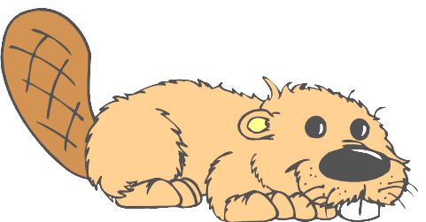

TRAIL MARKER 2
ANIMAL TRACKS



Many animals use the banks of a river as a pathway. It is possible to identify the kinds of animals that live here by looking at the tracks in the muddy bank. The most common track is that of a raccoon because they like to find their food near water. Other animal tracks might be armadillo, skunk, mink, coyote, bobcat, squirrel, and opossum. If you look towards the far bank you might see tracks in the mud. The best time to look for tracks is after a rainstorm or after a snowfall.




TRAIL MARKER 3
FALLEN TREE

This tree fell along with many others when a wind storm blew through the cities of Carrollton and Farmers Branch. The Tree was probably weak from insect damage which made it easier for the wind to blow it down. This event has created a new habitat for plants and animals. If you look up you can see that more sunlight now reaches the area. The extra sunlight helps other smaller trees grow and fill in the open space. As the fallen tree rots or decomposes, it will create homes for many insects and small animals.

TRAIL MARKER 4

ARMADILLO HOME

Armadillos are excellent diggers and make their homes by burrowing underground. The homes usually have more than one entrance and the armadillos may make more than one burrow. Armadillos have a hard shell-like cover that protects them from animals that might eat them. The armadillo might appear to look like a reptile but it is in the mammal family. Having hair is a characteristic of mammals and armadillos do have a small amount of hair on their belly. The female armadillo almost always gives birth to four babies. Armadillos come out of their burrows at night and began rooting around in the dirt for bugs and worms to eat. They are also one of the few animals that destroy fire ant mounds looking for the ants' eggs and larvae to eat.





TRAIL MARKER 5
CHANGING RIVER

As a river flows, it slowly removes dirt and plants from the edge of its bank. This process speeds up each time heavy rains occur. This numbered post (5) may someday fall into the river as the dirt is washed away. Many trees have already fallen into the river and the pathway has been changed due to erosion. You may be able to see a other trees leaning over the river. This process also causes dirt and plants to fill in on the other side of the river. Over long periods of time the river will change its course.

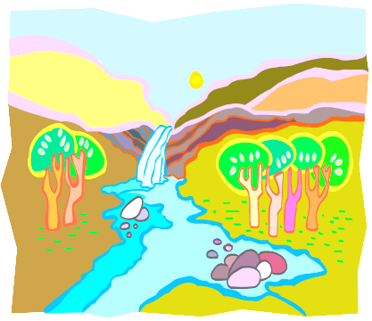
TRAIL MARKER 6

ANIMAL BRIDGE

If you look you can see a tree leaning out over the river.
On the far bank another tree is leaning out towards the
one on this side. The branches of both trees are touching
near the middle of the river. As the river washes away dirt
that supports the tree it begins to lean over and will eventually
topple over and get washed down stream. These two
trees now serve as a bridge for animals to cross the river
without getting wet. Many types of animals will use the
temporary bridge to find food or shelter on the other
side of the river. One group of students saw a bobcat
cross over the bridge.
TRAIL MARKER 7
GREEN BRIER PATCH

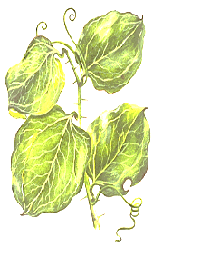
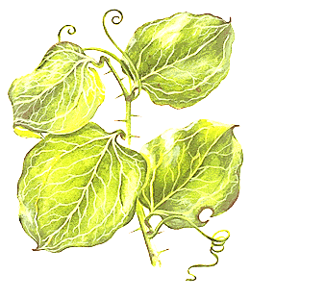
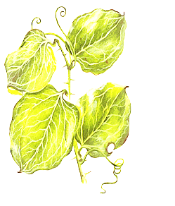
Green Brier is a thorny vine that grows in wooded areas. It has heart-shaped leaves and dark blue berries appear in the fall. Many small animals make their homes under briar patches because they are protected from bigger animals that are hunting for food. The thick brushy patches make it hard to walk through, so watch your step or you might get caught in the thorns of a brier patch.
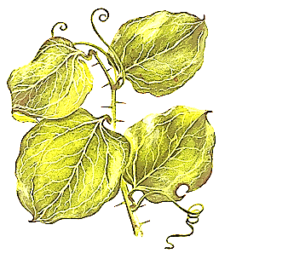


TRAIL MARKER 8

HIGH WATER MARK
Did you notice the trail dip down as you move closer to the river? This little ridge is called the high water mark. During heavy rain storms the river usually rises to this level. Whenever you go camping it is always good to locate the high water mark before setting up your tent. Otherwise, you might find yourself getting really wet.

TRAIL MARKER 9
POISON IVY VINES

Poison Ivy grows as small bushy plant or as a vine growing up the side of a tree or any other object such as this fence. It grows mainly in shady areas where the sunshine is not so intense. You can recognize Poison Ivy by its three leaflets on each leaf and a reddish color where the three leaflets come together. It also has a brown stem with some fuzzy hair-like bark and white berries that appear in late summer. You can get a very itchy rash if the sap from the plant gets into the pores of your skin.
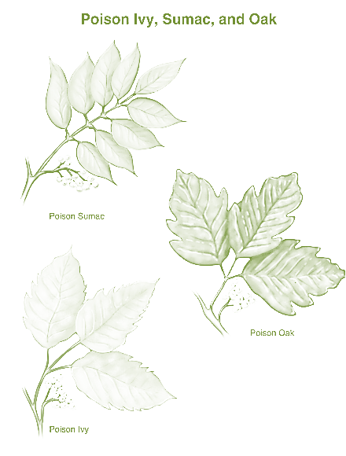

©2007 Relay Health and its affiliates

TRAIL MARKER 10
LEANING TREE

This tree is not growing down by the river where the dirt is washing away so why is it leaning? In this case, it is because the tree is growing in the direction where it can receive the most sunlight. Many trees near the edge of the woods or forest will grow this way. In west Texas, strong southerly winds blow hard enough to cause trees to lean as they grow. If you ever need to know which way is north is in west Texas, you can look at the trees. They usually lean to the north away from the southerly breezes.



