TEACHER LED ACTIVITIES
CAMOUFLAGE GAME

OBJECTIVE:
The students will become familiar with the concept of natural selection by means of a game, which uses camouflage and structural adaptations.

MATERIALS:
- Colored Popcorn Kernels (same amount of each color)
- Big Book - Animals in Hiding

PROCEDURE:
- Scatter a container of colored popcorn (equal numbers of each color) over a grass area. (approx. 25 foot diameter circle)

- Prepare the action by explaining to the students that camouflage plays an important role in adaptation (everything grows to fit where and how it lives). Many plants and animals have adapted to the place where they live in the protective coloration, which helps hide them from predators. Suggest to the students that the colored popcorn represents different kinds of insects, and that they are birds catching the insects.

- Lead the group to their "feeding grounds" where everyone collects as many kernels of popcorn as possible in one minute.

- Sort the popcorn kernels collected into colored piles and tally (compare) how many of each color were retrieved. The results should set the stage for a discussion of adaptive traits. For instance, ask the students which colored kernel (insect) might survive best.

- Now, divide the students into two groups. One group will be one kind of bird (Pinchers) and the other group will be another type of bird (Scissors). These names are based on the type of bill that each bird has. The horny extended bill serves as both hand and mouth for the bird. It enables the bird to preen (dress) its feathers, arrange its nest, and - of most importance - obtain and "manage" food. Each bird's beak is adapted and suited to that bird's particular habitat and the way in which that bird satisfies its basic needs within that habitat.

- Again scatter the popcorn kernels that were collected in the same area.

- Begin by showing students how to hold their fingers so that the "Pinchers" have their thumb and pointer finger unhampered and the "Scissors" have their pointer and middle finger unhampered. This will allow for a structural difference in the bills of the two different types of birds. (see diagrams 1 and 2)

- Repeat step 3 and then have each group of birds place their collected kernels into one large pile. (Separating the corn into colors is not necessary for this part of the activity.)

- Have students compare the two piles of popcorn. Now ask the students which bird species ("Pinchers" or "Scissors") might survive best. The pincher bird should have a better adapted bill (thumb and pointer finger) for gathering food (kernels).

- Ask students to think of examples of camouflage or other structural differences, which occur naturally in the environment.

- Show (read) students the Big Book Animals in Hiding. Students should hopefully be able to answer the question in the back of the big book which is “Can you guess why the bird watcher is wearing forest colors?”

DIAGRAM I PINCHERS

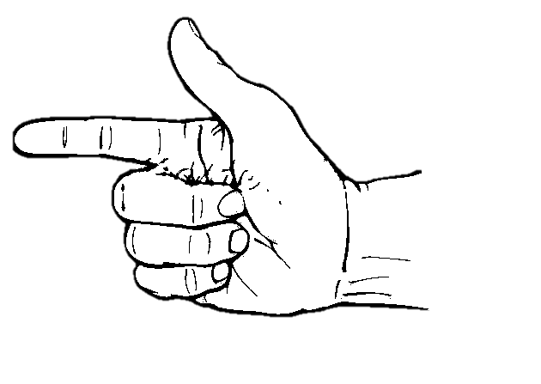

DIAGRAM II SCISSORS

